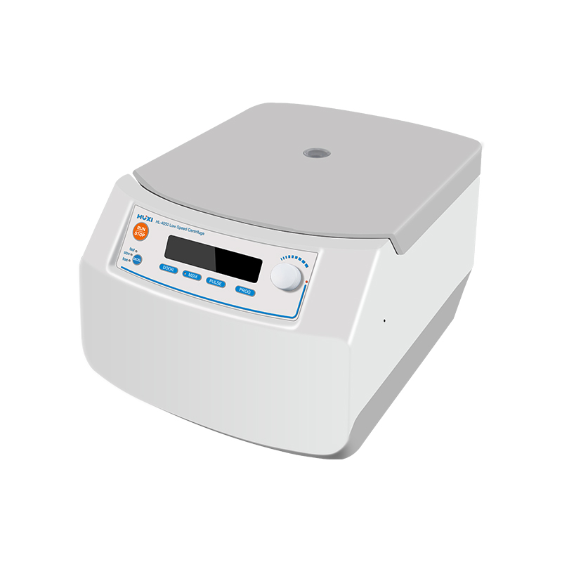

# **HL-4050 Low Speed Centrifuge**

# **Shaker**

# HT-S330 **Rotary Shaker**

**Application：**

HL-4050 low-speed centrifuge is a routine instrument used for centrifugal sedimentation in the laboratory. HL-4050 has a maximum speed of 4500rpm, wide voltage design is reasonable, adopts a miniature brushless DC motor, fast lifting and lowering speed, dust-free, maintenance-free, and unique MSM operation mode, this instrument is widely used in clinical medicine, biochemistry, immunology, blood station and other fields.

**Main Features：**

* 9 groups of custom program storage, 4-speed speed reduction curve;
* Maintenance-free DC brushless motor;
* Unique MSM operation mode, slow ramp-up/down operation mode;
* Automatic fault diagnosis;
* Wide voltage design, speed is not affected by grid fluctuation;
* Dynamic balance design, low noise structure, small amplitude.

**Technical Parameters：**

|  |  |
| --- | --- |
| Model | HL-4050 |
| Item No | 1010022001 |
| Speed Range(rpm) | 300~4500 |
| Speed accuracy(rpm) | 10 |
| Centrifugation range(×g) | 100~2500 |
| RCF accuracy(×g) | 10 |
| Max Volume | 50ml×6 ,15ml×6,2ml×12 |
| Standard volume | 6×50ml |
| Speed display | LCD |
| Timer set | 10s~99min |
| Working mode | Continuous |
| Noise level(dB) | ≤55 |
| Power Supply | AC110V-240V, 50Hz/60Hz, 3A |
| Exterior Dimension(mm) | (L)292 * (D)405 * (H)226 |
| Weight(kg) | 10 |